

**Smart Manufacturing Dashboard Development Report**



Table of Contents

**1. Introduction** 2

**2. Website Design and Code Decisions** 3

**2.2 About Us Page** 3

**2.3 Contact Us Page** 4

**2.4 Navigation and Responsive Design** 5

**3. Database ER Diagram** 5

**Entities:** 5

6

**4. Site Map** 6

**5. Implementation of HTML, JS, and PHP** 6

**5.1 HTML and CSS** 6

**HTML** 6

**CSS** 7

**5.2 JavaScript** 7

**5.3PHP** 8

**6. Validation and Security** 8

**7. Conclusion** 9

**8. References** 9

# 

# **1. Introduction**

The Smart Manufacturing Dashboard is a full of features online platform created to make it easier to manage, monitor, and optimise manufacturing processes in real time. Industry 4.0 is forcing a shift in the industrial sector towards more data-driven, efficient tools. This need is fulfilled by our dashboard, which gives factory managers, operators, and auditors the capacity to monitor performance, see important operational indicators, and make sure that production processes are running smoothly.

The objective of this project was to create an easy-to-use interface that incorporates sophisticated features such as secure user authentication, real-time data visualisation, and a responsive design that can be adapted to many kinds of devices. The platform's main goal is to provide customers with a user friendly, simplified environment in which to monitor factory operations, optimise performance, and generate reports.

We used current web technologies to create a scalable and reliable system as part of our design and development process. To guarantee cross-browser compatibility and responsive behaviour, the front end was created with HTML5, CSS3, and JavaScript. PHP was used to handle form submissions, maintain user sessions, and communicate with a relational database that houses reports, user profiles, and factory data, among other necessary data for back-end operations.

Finally, in order to guarantee the security and dependability of the system, we put strict validation and security measures in place, such as client-side and server-side form validation, password encryption, and SQL injection protection. This report ensures that the platform satisfies the high standards needed for industrial applications by providing a thorough overview of the development process and reasons for the decisions made.

# **2. Website Design and Code Decisions**

**2.1 Home Page**

The homepage, which offers a summary of the platform's main features and capabilities, was intended to serve as users'primary point of entry. The page has the following features:   
  
• A responsive navigation bar with links to the important sections (Home, About Us, Contact Us, Login, Register).

• A slider displaying pictures of Industry 4.0 technologies and a content section explaining the Smart Manufacturing Dashboard.

• A footer with contact details and social media links.  
  
For a neat, polished layout, the webpage was coded in HTML and decorated with CSS. A smooth image slider was made with JavaScript to improve user engagement.

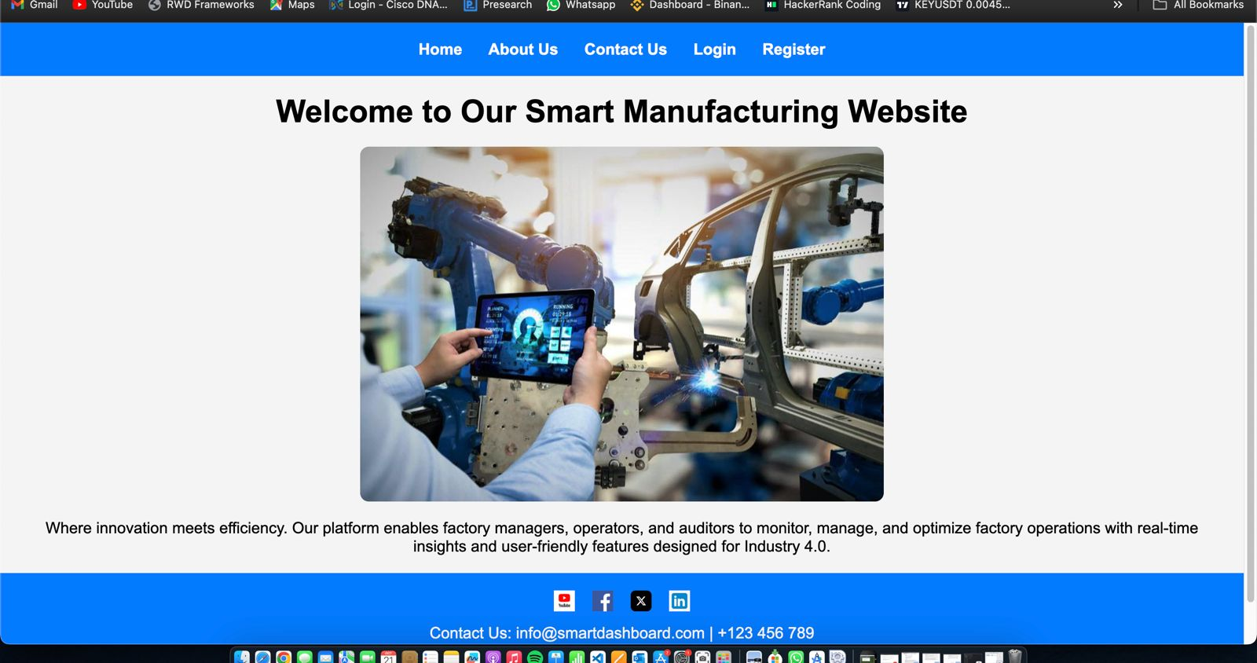

## **2.2 About Us Page**

Background information regarding the Smart Manufacturing Dashboard and its function in enhancing manufacturing processes can be found on the "About Us" page. Important components consist of:  
  
• A straightforward layout with a focus on content that is meant to be both readable and educational.

• To keep users familiar, the footer and navigation designs are consistent with the home page.

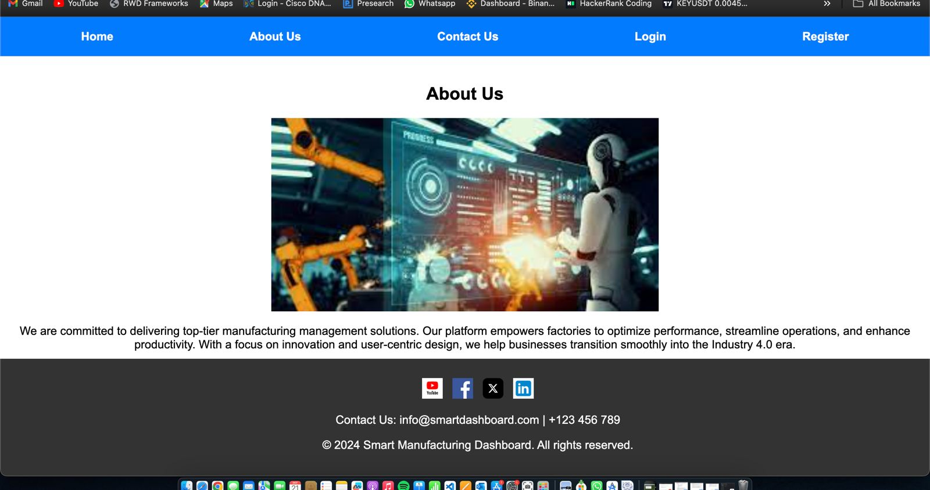

## **2.3 Contact Us Page**

In order to facilitate efficient communication between users and the Smart Manufacturing Dashboard support staff, the "Contact Us" page is essential. This page's design was based on the principles of practicality and simplicity. It has the following essential components:  
  
Contact Information: Users can easily reach out for support or questions by using the page's direct access to important contact information, including a phone number and email address.

Social Media Integration: Clickable icons in the page's footer connect users to the platform's social media accounts on Facebook, LinkedIn, YouTube, and Twitter (X). In addition to being aesthetically pleasing, these symbols give consumers additional methods to contact support or remain informed about platform announcements.

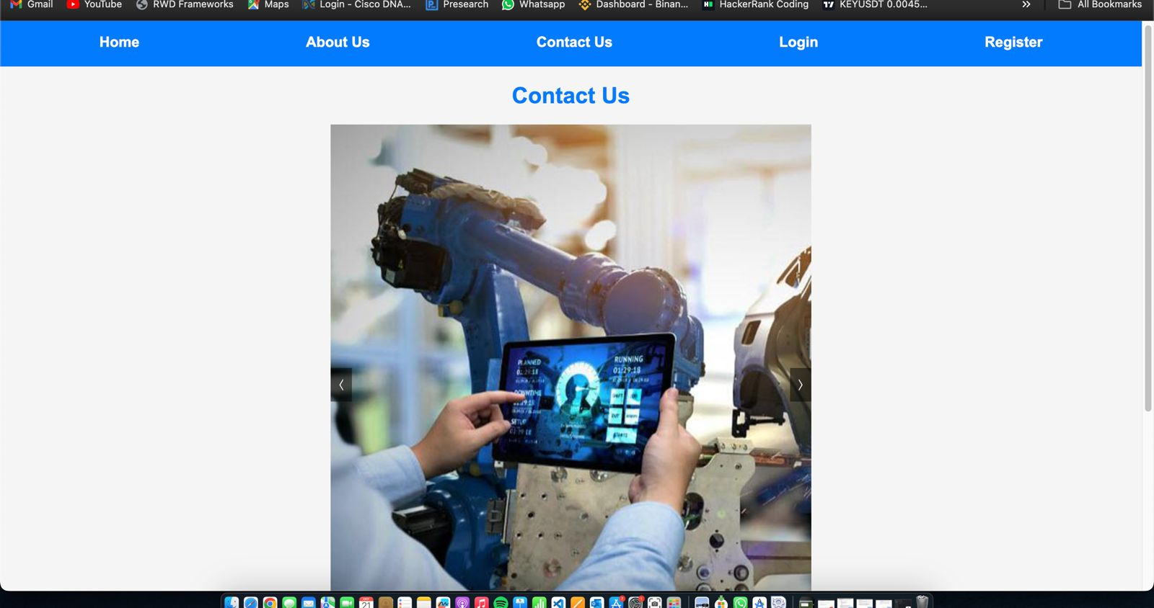

## **2.4 Navigation and Responsive Design**

The Smart Manufacturing Dashboard's navigation bar is a crucial part of the user experience since it gives consumers rapid and reliable access to the site's most crucial areas. The navigation bar's design adheres to a number of guidelines to guarantee responsiveness and usability:  
  
The important pages (Home, About Us, Contact Us, Login, Register) are listed in a clear, structured, and semantically suitable manner thanks to the navigation links' arrangement within an unordered list (<ul>)  
  
Consistency Across Pages: The website's navigation bar is made to seem the same on all of its pages, including Home, About Us, and Contact Us.

# **3. Database ER Diagram**

The database for the Smart Manufacturing Dashboard stores key information, including user credentials and operational data. The ER diagram was developed to represent the relationships between the various entities such as users, factory data, and reports.

## **Entities:**

* Users: Store user details for login and role-based access.
* Factories: Contain factory-specific information.
* Reports: Store operational reports generated through the dashboard.

# **4. Site Map**

The site map outlines the hierarchical structure of the website, which includes:

* Home
* About Us
* Contact Us
* Login
* Register

Each of these page’s links to the main sections required for users to navigate the platform efficiently.

# **5. Implementation of HTML, JS, and PHP**

## **5.1 HTML and CSS**

The Smart Manufacturing Dashboard's visual and structural design was based primarily on HTML and CSS. The website's foundation was constructed using these technologies, guaranteeing its accessibility, responsiveness, and aesthetic appeal.

### **HTML**

Each page's structure, including the homepage, About Us, and Contact Us sections, was defined using HTML, the primary markup language. Its semantic components were used to produce a well-structured and user-friendly layout that enhanced accessibility for both search engines and users.

Among the project's primary uses of HTML are:

Page Structure: Semantic HTML tags were used in the construction of each page to clearly designate its many sections. For instance, the navigation bar was placed inside the element, while contact details and copyright were placed inside the tag. The primary material, like the homepage's introduction or the About Us page's mission statement, was put within the tag. The website's accessibility is improved by this semantic organization, which guarantees that assistive technologies can read it.  
  
  
Content Organisation: Headings, paragraphs, images, and other types of content were all logically and clearly organised by HTML. By ensuring appropriate content hierarchy using heading tags (<h1>, <h2>, etc.) the website became easier for search engines and users to navigate.

### **CSS**

To specify the website's visual style and guarantee that it was aesthetically beautiful and consistent across various devices, CSS was heavily utilised. CSS made it possible to fine-tune the website's responsiveness, fonts, colours, and layout. Important elements of using CSS include:

Layout & Positioning: The ability to efficiently arrange material across a range of screen sizes was made possible through CSS. For example, the navigation bar's flexbox structure guarantees that links are positioned uniformly and adapt to the width of the screen. The image slider on the home page and other <div> content containers were formatted to guarantee that the elements were properly aligned and spaced apart.

Responsive Design: Making sure the website was responsive was one of the key design elements. In order to ensure optimal presentation across a variety of devices, including desktops and smartphones, media requests were used to modify styles based on screen size. To ensure that users on mobile devices can easily engage with the site, for instance, the navigation bar's structure and the slider's dimensions automatically adjust to fit smaller screen sizes.

## **5.2 JavaScript**

JavaScript was essential to the Smart Manufacturing Dashboard's dynamic behaviour, which improved user engagement and involvement. The structure and styling were established using HTML and CSS, but JavaScript was in charge of developing the interactive elements that enhanced the user experience.  
  
Image Slider Implementation  
The project's implementation of the image slider on the home page was one of the main uses of JavaScript. The slider showcases elements of Industry 4.0 technologies by automatically navigating through a collection of photographs, giving the website a dynamic and contemporary feel. This feature keeps the page dynamic and interesting while giving users a visual overview of the platform's main points.

## **5.3PHP** PHP was used to manage the Smart Manufacturing Dashboard's dynamic features, including server-side operations like database interaction, form processing, and user authentication. PHP acted as a link between the front-end interface and the back-end database since the platform needed safe access control and user management.

* User authentication, which guarantees that only authorised users can access important data and functionalities, is one of the platform's key features. Because PHP was used in the development of the login and registration pages, the following actions were made possible:
* User Registration: Using a form, new users can create an account. Both client-side (using HTML attributes and JavaScript) and server-side (using PHP) validations are performed on the provided data, including username, password, and email. Following validation, the information is safely kept in the database, and passwords are hashed using password_hash() to keep plain-text passwords private.
* Login System: When users enter their login information, their username and password are compared to the database entries. PHP's password_verify() function makes sure that passwords are safely compared without disclosing private information, even if they have been hashed in the database.
* Session management makes sure users stay authenticated while navigating the website by assigning them a session after they log in. To prevent unwanted access to sensitive features or data, this session data is safely saved and verified on every page that needs restricted access.

# **6. Validation and Security**

Several levels of validation and security measures were put in place across the Smart Manufacturing Dashboard to guarantee a safe and useful platform. In order to preserve data integrity, stop security breaches, and guarantee a flawless user experience, these procedures were essential. To improve server-side and client-side security, the following steps were added.

## **HTML Form Validation**

The first line of defence was HTML form validation, which offered client-side verification to make sure that the form's fundamental input criteria were satisfied before sending it to the server. This enhances user experience and overall efficiency by preventing inaccurate or incomplete data from being delivered to the back end.  
  
**required Attributes**: To make sure users didn't leave crucial fields like email, username, and password empty, required attribute was applied to forms like login, registration, and contact.

* Example:

html

<input type="email" name="email" required>

**Input Types**: To guarantee that the data entered was in the right format, appropriate input types were utilised, including email, password, and number. For instance, the password type conceals user input for security and privacy, while the email type guarantees the user enters a legitimate email address.

* Example:

<input type="email" name="email" required>

<input type="password" name="password" required>

## **PHP Validation and Security**

PHP was used to implement server-side validation and security checks to guard against any manipulation or bypassing of client-side validation. These safeguards are essential for protecting user data and stopping harmful attacks like brute-force and SQL injection.

**Server-Side Data Validation**: User-provided data is revalidated on the server side once the form is submitted. This involves ensuring that all necessary fields, appropriate formats, and acceptable input values are present. The form is denied, and users are informed with the relevant error messages if any validation fails.

* Example:

php

if (!filter_var($email, FILTER_VALIDATE_EMAIL)) {

echo "Invalid email format";

}

# **7. Conclusion**

In order to establish a platform that satisfies the demands of contemporary manufacturing businesses, the Smart Manufacturing Dashboard's development successfully integrated user-centred design, strong functionality, and solid security measures. The seamless integration of the front-end and back-end components was carefully considered throughout the project to give users an easy-to-use and effective tool for controlling and optimising factory processes.

A refined and expert user experience was provided by the platform's HTML and CSS structure, which guaranteed a consistent and responsive layout across several devices. Most significantly, JavaScript's implementation of the picture slider, which gave the homepage a dynamic visual element, improved the site's engagement.

PHP was essential to the back-end management of user authentication and safe database interaction. In addition to client-side checks and server-side validation, prepared statements and password hashing guaranteed the safe storage of user credentials. Common security risks like SQL injection and brute-force attacks were successfully reduced by combining these strategies.

In conclusion, the Smart Manufacturing Dashboard was created to satisfy industry requirements for security, functionality, and usability. With an emphasis on user experience and data security, the platform provides a dependable option for managing and monitoring industrial operations in real-time. It can also assist Industry 4.0 developments. The dashboard's adaptable and scalable design puts it in a good position for future additions and modifications to satisfy changing industry demands.

# **8. References**

*How smart manufacturing could lead to an industrial renaissance*. (n.d.). Schroders. <https://www.schroders.com/en/global/individual/insights/how-smart-manufacturing-could-lead-to-an-industrial-renaissance/>

*Premium Photo | Mechanized industry robot and robotic arms for assembly in factory production .* (2021, October 5). Freepik. <https://www.freepik.com/premium-photo/mechanized-industry-robot-robotic-arms-assembly-factory-production_19128519.htm>

*Website Security 101: How to secure your website | Mailchimp*. (n.d.). Mailchimp. <https://mailchimp.com/resources/website-security/>

